National Core Arts Standards in Music

Dr. Wendy Barden wbarden@seguecp.com
Artistic Literacy is about Creating, Performing, and Responding to music

When students leave school, we want them to be ready for college, career, life and that includes
doing what musicians do: being able to communicate ideas through music as both the sender and receiver.

NCAS were developed on Understanding by Design (UbD) Framework ® of McTighe & Wiggins
- Enduring Understandings (in teacher language)
- Essential Questions (put them in age-appropriate language)
- Cornerstone assessments
“Like a cornerstone anchors a building, we think these tasks should anchor a curriculum because they reflect the most important things we want students to do with their learning.” McTighe

  - Establish the depth of knowledge, skills, and connections students are expected to reach
  - Multi-faceted, real-world tasks
  - Embedded in teaching and learning from the start
  - Milestone tasks recurring about every three years
  - Help teachers and students gauge progress towards the goal of artistic literacy
  - Model assessments are/will be included with NCAS resources to be used as is, or as examples for locally developed cornerstone assessment

NCAS: Layers of Detail
Arts areas: Dance, Media Arts, Music, Theatre, Visual Arts. There is strength in having collective arts standards, but also compromises to make them work for all.

Artistic processes: Artistic literacy is doing what musicians do. Creating, Performing, Responding to music. This layer of detail helps us (and the public) recognize general similarities in the arts areas.

Anchor standards: These standards are the same for all arts areas and all grades. This layer of detail helps building and district administrators understand connections and similarities among the arts. Note this term is also used in Common Core State Standards in ELA and Math, but here’s where the connection ends.
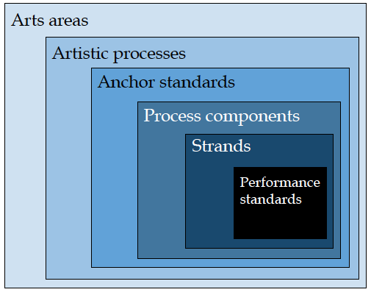

Process components: Music-specific. Work at this layer of detail in building or district music department discussions across multiple grades and music disciplines.

Strands: Five sets of music standards are similar but also address the uniqueness of each course of study. General music, Traditional & emerging ensembles, Harmonizing instruments (guitar, piano), Music composition/Theory, Music technology.

Performance standards: Standards are identified by grade-level in General music, and experience-level (novice through advanced) in the other strands. Work at this layer alone or with job-alike colleagues.

